|  |  |
| --- | --- |
|  | CoE Starter Kit – Setup Instructions |
|  |  |
|  | The Center of Excellence (CoE) starter kit is a collection of components and tools that are designed to help get started with developing a strategy for adopting and supporting the Power Platform, with a focus on Power Apps and Power Automate.  Download the most updated assets from the [**GitHub repository**](https://github.com/microsoft/powerapps-tools/tree/master/Administration/CoEStarterKit).  The entire content package can be downloaded directly at [**aka.ms/CoEStarterKitDownload**](https://aka.ms/CoEStarterKitDownload)  2/6/20 |

Contents

PreRequisites 3

Disclaimer 3

Purpose of this Document 4

Core components - Setup Instructions 4

Step 1: Import the solution 4

Step 2: Configure the CoE Settings entity 6

Step 3: Update Environment Variables 7

Step 4: Activate the Sync Template Flows 10

Step 5: Setup Audit Log sync 14

Step 6: Configure the Power BI Dashboard 17

Step 7: Share apps with other admins 19

Step 8: Wait for Flows to Complete 19

Audit and Report components - Setup Instructions 20

Step 1: Import the solution 20

Step 2: (Optional) Create a SharePoint document library 20

Step 3: (Optional) Create an azure ad security group 20

Step 4: Update Environment Variables 21

Step 5: iNITIALIZE Flow APPROVAL Entities IN YOUR ENVIRONMENT 22

Step 6: Activate the Flows 24

Step 7: Share apps with Makers 24

Nurture components - Setup Instructions 25

Step 1: Import the solution 25

Step 2: Update Environment Variables 25

Step 3: Activate the Flows 26

Step 5: Share apps with Makers 26

## PreRequisites

The following are prerequisites for installing the CoE starter kit as it comes in the solution.

1. **Admin account**
   1. [Power Platform Service Admin](https://docs.microsoft.com/en-us/power-platform/admin/use-service-admin-role-manage-tenant), Global tenant admin or Dynamics 365 service admin for access to all tenant resources through the Power Apps APIs.
   2. This solution will still work for Environment admins, but the view will be restricted to only the environments an Environment admin has access to.
   3. Dynamics 365 service admin is required for getting details on Model Driven Apps and Solution Aware Flows.
2. **PowerApps Premium License** (Per App, Per User or Dynamics 365 Online licenses)  
   This is for using the CDS solution.
3. **Environment with a CDS instance**, where the user installing the solution has System Administrator security role.
4. **Download of the Center of Excellence Solution** and Power BI dashboard files to your device.
5. Both the Audit and Report Components and Nurture components solution require the **Core Components solution to be installed**

These are the requirements for using the solution.

1. Power Apps Premium License (Per App, Per User or Dynamics 365 Online licenses)
2. For the **Core Components** solution, only the admins need a Premium License. For the Audit and Report Components, all makers require a Premium License. For the Nurture components, everyone will require Premium License.

|  |
| --- |
| Where the data comes from The “Admin | Sync Template” flows crawl through all the resources stored in the Power Platform and makes a copy of details in each resource (e.g., apps and flows) to the CDS (entity definitions are provided in this solution). All data displayed in most of the starter kit components are dependent on the data first being in CDS, which means that the sync template must be configured for everything else to work.  The Sync Flows run daily overnight. When you first set up the CoE Starter Kit, you can manually start the **Admin | Sync Template v2** which will start the process of crawling and storing the information in CDS. |

## Disclaimer

The Center of Excellence (CoE) Starter Kit is not supported by the Power Platform product team (which is true for all tools available in [this GitHub repo](https://github.com/microsoft/powerapps-tools)). We are a small team in Engineering who built this unsupported community sample solution for anyone to use and modify as their own, made available to customers on an as-is basis via an [MIT license](https://github.com/microsoft/powerapps-tools/blob/master/LICENSE). It’s possible you might run into some issues, such as installation problems, authorization issues, or bugs in the apps and flows within the solution.

Please, **do not raise support tickets for issues related to this toolkit** in the Power Platform Admin Center or any official product portal. Instead, kindly.

1. Make sure you have read through the entire documentation
2. If the issue is not addressed in the documentation, raise a new issue in the [issues tab](https://github.com/microsoft/powerapps-tools/issues) of this repository. Someone from the team will respond to your issue there.

## Purpose of this Document

This document is targeted toward the person or department responsible for setting up a Microsoft Power Platform CoE in their organization. The goal of the document is to walk you through the setup instructions for the individual components of the CoE Starter Kit.

For larger context of the CoE Toolkit, please read [CoE Starter Kit - Documentation and Setup Instructions](https://github.com/microsoft/powerapps-tools/blob/master/Administration/CoEStarterKit/CoE%20Starter%20Kit%20-%20Documentation%20and%20Setup%20Instructions.pdf)

# Core components - Setup Instructions

There are multiple components provided in this starter kit, each will require some configuration to install. The installation instructions have been segmented based on the set of components that should be grouped and installed together, and dependencies on other segments are outlined in each section.

## Step 1: Import the solution

Description

This is the first setup step of the installation process and is required for any other component in the starter kit to work.

First, import the Center of Excellence – Core Components solution but follow the same steps below once you are ready to install the Audit and Nurture components.

Instructions

1. Download the CoE starter kit compressed file ([aka.ms/CoeStarterKitDownload](https://aka.ms/CoeStarterKitDownload)), and extract the zip file. It will contain the solutions.
2. Create an Environment in which to set up the CoE.

Please see the following for information about [Sandbox](https://docs.microsoft.com/en-us/power-platform/admin/sandbox-environments) and [ALM](https://docs.microsoft.com/en-us/power-platform/admin/wp-application-lifecycle-management) generally.

* 1. Go to <https://admin.powerplatform.microsoft.com/>
  2. Select Environments, + New, and then fill in a name, type and purpose
  3. Select yes for creating the database, and click Next
  4. Leave sample apps and data to no, so that exploration of the CoE solution is easier, and then select a security group who can view this environment. Then hit Save

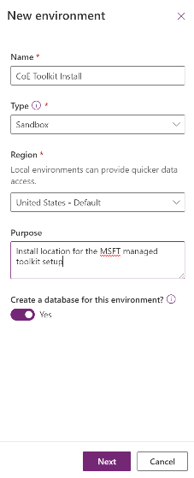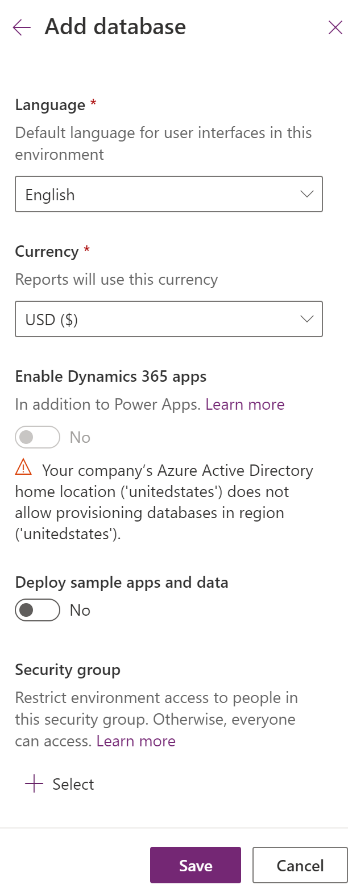

1. Go to this environment (or another **non-default** Environment where the solution will be installed)
   1. Go to <https://make.powerapps.com>
   2. Navigate to the Environment the CoE solution will be hosted in. In the screenshots example, we're importing to the Environment called 'Contoso CoE'.
2. Select Solutions on the left navigation bar.

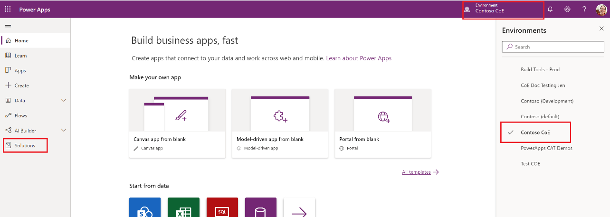

1. Select **Import**, and a pop-up window will appear (make sure to disable the pop-up blocker in your browser and try again if nothing happens when clicking the Import button).
2. In the pop-up window, select **Choose File**.  
   Import Solution - Google Chrome 
   https://org99b2e579.crm.dynamics.com/tools/solution/import/SolutionlmportWi... 
   Select Solution Package 
   Select the compressed (Zip or cab) file that contains the solution you Want to 
   i In rt and Click Next. 
   Choose File o file chosen 
   Help 
3. Choose the MANAGED **Power Platform** solution from the file explorer (CenterOfExcellenceCoreComponents_x_x_x_xx_managed.zip).
4. When the solution compressed (.zip) file has been loaded, click **Next**.
5. Review, click **Next**, then click **Import**. (This can take some time.)
6. When the import succeeds, the list of the components that were imported is displayed.

Note: Sometimes Flow components show a warning of type “Process Activation” and a duplicate record of that component. You can ignore these warnings for flows

**NOTE: Some users may get an Invalid Argument on trying to import the solution. This is due to a breaking change on the CDS side for pre-existing solutions on an older version that use Environment Variables. A fix is being rolled out and should be in all tenants in the next two weeks. In the meantime, if you are experiencing this issue, please import the solution in this folder:** [**https://github.com/microsoft/powerapps-tools/tree/master/Administration/CoEStarterKit/TEMP%20FIX%20for%20Invalid%20Argument%20Error**](https://github.com/microsoft/powerapps-tools/tree/master/Administration/CoEStarterKit/TEMP%20FIX%20for%20Invalid%20Argument%20Error)

1. Close out of the logs dialog.
2. Back on the Solutions page, click **Publish All Customizations**. This is good practice to follow whenever you make changes to a solution, but especially so when importing.

## Step 2: Configure the CoE Settings entity

Description

This section explains how to enter data in the CoE Settings entity, which is in the Common Data Service you instantiated. It represents the settings for components in the solution and should be completed second.

The steps below will have you fill this entity with a single row which contains your logo, brand colors and so on, which different applications will reference.

Dependencies

* **Canvas Apps**. The optional branding details (e.g., logo, brand colors) in all the canvas apps are pulled from this entity. Optional support and community channel links are also used.
* **Optional Flows**. The optional branding details and support channel links are used in the flows used for communication. You also will configure links to the canvas apps in the settings. The main flow that syncs data to the resource entities do not depend on this setting configuration.

Instructions

1. Navigate to <https://make.powerapps.com/>, click on Apps and open the Power Platform Admin View model driven app in Play mode.
2. In the left navigation, click on Configure (under Settings)
3. In the Settings view screen, click on “+ New” to create a new record
4. Provide values

|  |  |
| --- | --- |
| Brand Logo | Link to your Brand Logo |
| Brand Logo | Link to your Logo as an image file |
| Brand Primary Color | HEX Value of your primary brand color (#cccccc) |
| Brand Secondary Color | HEX Value of your secondary brand color (#dddddd) |
| Email End User Support | Email Address for your Helpdesk or EUC Support Team |
| Email Maker Support | Email Address for your Power Platform Maker Support Team |
| Link to Community Channel | Link to your internal Power Platform Community (Yammer, Teams) |
| Link to Learning Resource | Link to internal Power Platform Learning Resources or Training or you could link to aka.ms/PowerUp |
| Link to Policy Documentation | Link to internal Power Platform Policies, these could be hosted in a Teams Channel or SharePoint site |
| Version | Set to 1.0 |

1. Save by clicking CTRL + S or by clicking the Save button in the bottom right corner.
2. Do not add more records to the CoE Settings table, there is no need. The dependent components will always get values from the first record so there only needs to be one record in this table.

## Step 3: Update Environment Variables

Description

This step should be completed after the first two steps above. The Environment Variables are used to store application and flow configuration data with data specific to your organization and/or environment. This means, you only have to set the value once and it will be used in all necessary flows and apps.

Dependencies

All of the ‘Sync’ flows depend on all Environment Variables being configured.

Instructions

You will see an error at the top, notifying you that Environment Variables need to be configured.   
Note: For the Core Components solution, it will be **3** environment variables that need to be configured.  


While you can click directly on this link to edit them, the steps below show you how to access the variables after this alert is dismissed.

1. Go to the **Default Solution** solution.
   1. Navigate to <https://make.powerapps.com> and set the current Environment to the same Environment where the Center of Excellence solution is installed
   2. In the left navigation, click on **Solutions**, then select the **Default Solution** solution
2. Filter the Default Solution to only show Environment Variables by changing the view to Environment variable on the right hand side  
   
3. Click on a variable and configure the **Default Value**   
   A screenshot of a cell phone

   Description automatically generated
4. You will configure the following Variables for the Core Components solution

|  |  |
| --- | --- |
| Power Automate Environment Variable | For a US environment <https://us.flow.microsoft.com/manage/environments/>  For an EMEA Environment  <https://emea.flow.microsoft.com/manage/environments/> |
| Admin eMail | eMail address used in flows to send notifications to Admins, either your email address or a distribution list |
| eMail Header Style | CSS Style used to format emails that are sent to admins and makers. |

We recommend the following value for the eMail Header Style:

<head> <style>

body {

background-color: #efefef;

font-family: Segoe UI;

text-align: center;

}

#content {

border: 1px solid #742774;

background-color: #ffffff;

width: 650px;

margin-bottom: 50px;

display: inline-block;

}

#logo {

margin-left: 52px;

margin-top: 40px;

width: 60px;

height: 12px;

}

#header {

font-size: 24px;

margin-left: 50px;

margin-top: 20px;

margin-bottom: 20px;

}

#ribbon {

background-color: #742774;

}

#ribbonContent {

font-size: 20px;

padding-left: 30px;

padding-top: 10px;

padding-bottom: 20px;

color: white;

width: 100%;

padding-right: 10px;

}

#message > td {

font-size: 14px;

padding-left: 60px;

padding-right: 60px;

padding-top: 20px;

padding-bottom: 40px;

}

#footer > td {

font-size: 12px;

background-color: #cfcfcf;

height: 40px;

padding-top: 15px;

padding-left: 40px;

padding-bottom: 20px;

}

#form {

width: 100%;

border-collapse: collapse;

}

#app {

width: 60%;

font-size: 12px;

}

.label {

color: #5f5f5f

}

table {

border-collapse: collapse;

width: 100%;

}

th, td {

padding: 8px;

text-align: left;

border-bottom: 1px solid #ddd;

}

</style> </head>

1. Confirm values by clicking **Save**

## Step 4: Activate the Sync Template Flows

Description

This step should be completed after the first three steps above. The flows with the prefix ‘Sync’ are required for populating data in the ‘resource’ related CDS entities (Environments, PowerApps Apps, Flows, Connectors and Makers).

Dependencies

The ‘Sync’ flows are used to write data from the admin connectors into the CDS entities. None of the other components will work if the Sync flows aren’t successfully configured and have executed.

Required Flows to sync data to the resource entities:

1. **Admin | Sync Template v2**  
   Flow type: Scheduled (daily by default)  
   Description: This flow syncs environment details to the CoE CDS Entity ‘Environments’
2. **Admin | Sync Template v2 (Apps, Custom Connectors, Flows, Model Driven Apps)**Flow type: Automated  
   Description: This flow rely on the Admin | Sync Template v2 and are triggered automatically when environment details are created or modified in the CoE CDS Entity ‘Environments’. These Flows then crawl environment resources and store app, flow, connector data in the entities ‘PowerApps App’, ‘Flow’, ‘Connection Reference’, ‘Maker’.
3. **Admin | Sync Template v2 (Connectors)**Flow type: Scheduled (daily by default)  
   Description: This flow stores all connector information in the CDS Entity ‘PowerApps Connector’.
4. **Admin | Sync Template v2 (Sync Flow Errors)**Flow type: Scheduled (daily by default)  
   Description: If any of the Sync flows fail, the failure is stored in the CDS Entity ‘Sync Flow Errors’. This scheduled flow sends a report of failures to the admin.

Instructions

The flows are all stored in the solution. It is automatically available in the Environment when you import the solution, but there are two options to consider for activation of the flows. Option 1 takes longer to configure than option 2 but is also easier to receive updates.

#### Option 1: Keep Flow in the solution and update each action connection

Use this option if you would like to continue receiving updates to the flow through this solution. This takes longer to set up because the connections for each action need to be individually configured.

1. Go to the Center of Excellence - Core Components solution.
   1. Navigate to <https://make.powerapps.com> and set the current Environment to the same Environment where the Center of Excellence solution is installed
   2. In the left navigation, click on **Solutions**, then select the **Center of Excellence - Core Components** solution
2. Click on the flow name to get to the details screen, then select ‘Edit’ 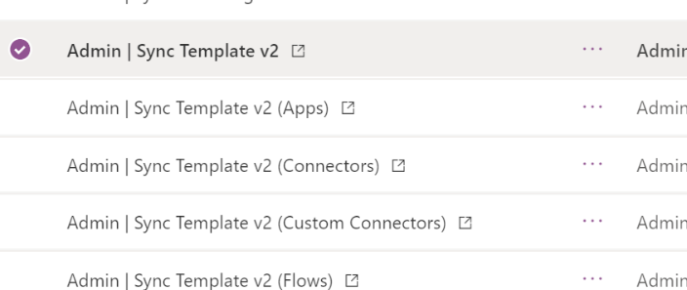
3. The flow will open in the maker studio. For each action that requires a connection, there will be a warning icon on the right side of the action. This indicates the need for a connection to be selected.  
   A screenshot of a cell phone

   Description automatically generated

If, when you hit save, you see this error, that means that there are more connections that still need made, likely hidden in conditional nodes.

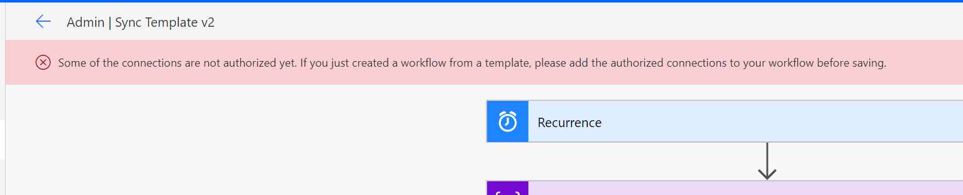

* 1. Some connections will need to be created if not already available
  2. Some actions might be hidden within other built in actions, such as a condition or scope. Expand these actions to find the hidden ones
  3. Suggest you start at the top of the flow and work down, opening each step as you go down, step by step until you find them all.

1. Once all actions have a connection, save the flow.
2. Repeat the above steps for Admin | Sync Template v2 – Apps, Connectors, Custom Connectors, Flows, Model Driven Apps and Sync Flow Errors
3. Ensure the flows are Turned On
4. Trigger the sync flows to populate your data
   1. Click on Admin | Sync Template v2
   2. This will open a new tab to the flow’s details page.
   3. Click Run in the Ribbon

#### Option 2: Save a copy of the Flow outside of the solution

Save a copy of the flow from the solution and the connections are created automatically for you. The drawback from this method is that if you copy the flow from the solution, the copy flow does not get updated when you update the solution package with newer versions. You will just have to import the individual flow package updates instead or re-install the updated versions.

1. Go to the Center of Excellence - Core Components solution.
   1. Navigate to <https://make.powerapps.com> and set the current Environment to the same Environment where the Center of Excellence solution is installed
   2. In the left navigation, click on **Solutions**, then select the **Center of Excellence - Core Components** solution
2. Click on the display name of the flow you want to enable. This will open a new tab to the flow’s details page.  
   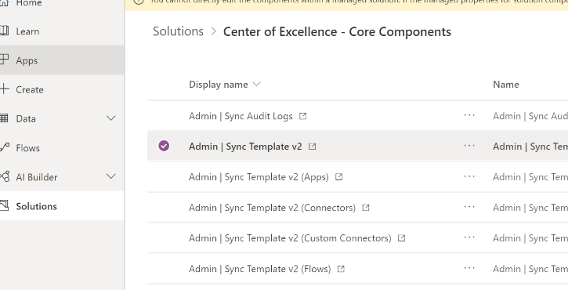
3. Select **Save As** in the ribbon  
     
   A screenshot of a cell phone

   Description automatically generated
4. A window will popup saying, “We’ll create these connections for you”. Click Continue.  
   A screenshot of a computer

   Description automatically generated
5. Rename the copy if desired. Click **Save**.   
   A screenshot of a cell phone

   Description automatically generated
6. At this point, the copy has been created. You can view the flow in the **My** **Flows** page in the left navigation. Remember that the copy of the flow will NOT be visible in the Center of Excellence – Core Components solution.
7. Repeat the above steps for Admin | Sync Template v2 – Apps, Connectors, Custom Connectors, Flows, Model Driven Apps and Sync Flow Errors
8. Turn each flow on
   1. Click on each flow
   2. This will open a new tab to the flow’s details page.
   3. Click Turn On in the Ribbon
9. Trigger the sync flows to populate your data
   1. Click on Copy of Admin | Sync Template v2
   2. This will open a new tab to the flow’s details page.
   3. Click Run in the Ribbon

## Step 5: Setup Audit Log sync

Description

This flow connects to the Office 365 Audit Log to gather telemetry data (unique users, launches) for Power Apps apps. The flow uses a custom connector to connect to the Office 365 Audit Log. In the instructions below, we will setup the custom connector and configure the flow.

Dependencies

The usage information in the Power BI dashboard depends upon this step being complete.

Known Issues

If your Admin account is protected with MFA, using Basic Authentication to authenticate will not work. We are working on documentation for setting the custom connector up for accounts that use MFA.

Instructions

Make sure the account that is used to configure this section has permission to access the audit logs. Global tenant admins have access to the audit logs by default and can grant access to the audit logs for other user accounts or groups through the Exchange Admin Center.

Keep in mind that once a user account has access to the audit logs, they have access to all audit logs across every Microsoft service that reports telemetry to audit logs.

1. Install the custom connector
   1. Go to <https://flow.microsoft.com> and set the current Environment to the same Environment where the Center of Excellence solution is installed.
   2. In the left navigation, expand Data and click Custom Connectors
   3. Click + New custom connector – Import an Open API file
   4. Provide a connector name (Office 365 Audit Logs) and select the .swagger file that is which can be found in the CoE Starter Kit pack you downloaded.  
      A screenshot of a social media post

      Description automatically generated
   5. Click on **Create Connector**
   6. You don’t need to change the Security and Definition information, to test the connector select 4. Test  
      
   7. Click on New Connection to create a connection to your connector  
      A screenshot of a cell phone

      Description automatically generated
   8. Enter the email address and password of the user that has access to the Audit Logs in the connection window and select Create connection  
      A screenshot of a cell phone

      Description automatically generated
   9. Select the refresh icon in the right-hand corner of the Connections area to ensure the new connection is selected
   10. Provide a Start Date and End Date for the GetActivitiesByOperation   
       A screenshot of a cell phone

       Description automatically generated
   11. Click **Test Operation**
   12. You should receive a (200) response which indicates a successful execution of the query  
       A screenshot of a cell phone

       Description automatically generated
   13. You can find more information on how to configure a custom connector here: <https://docs.microsoft.com/en-us/connectors/custom-connectors/define-openapi-definition#import-the-openapi-definition>
2. Import the Flow Template compressed (.zip) package called SyncAuditLogs.zip.
   1. Go to <https://flow.microsoft.com> and set the current Environment to the same Environment where the Center of Excellence solution is installed.
   2. In the left navigation, navigate to the My Flows tab
   3. Click Import in the top
   4. Select the **Flow-SyncAuditLogs.zip** package, click import
   5. Connect the connections
      1. Click on each of the red icons shown to configure

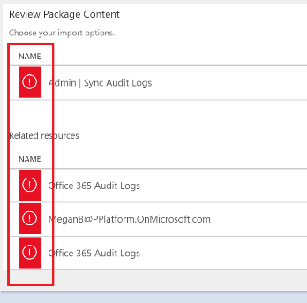

* + 1. For Admin | Sync Audit Logs, select to Create as new, and Save
    2. For the rest, chose to Select on input, and chose the option given

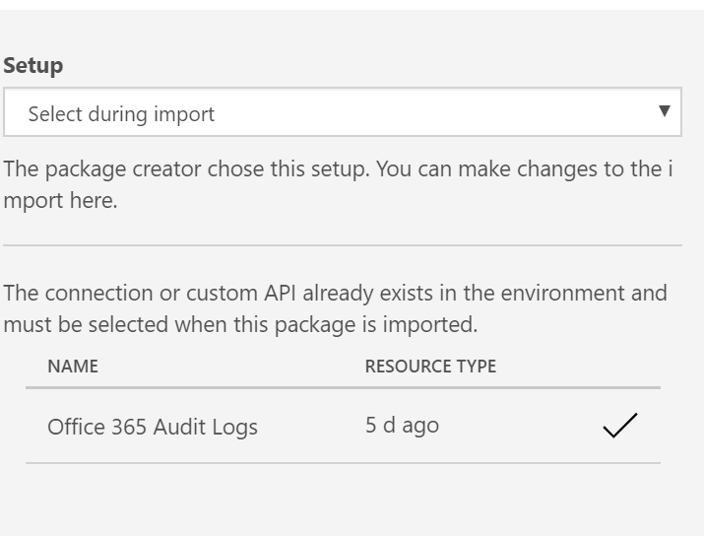

* + 1. Once you select these the icon will show as an x until you hit Import

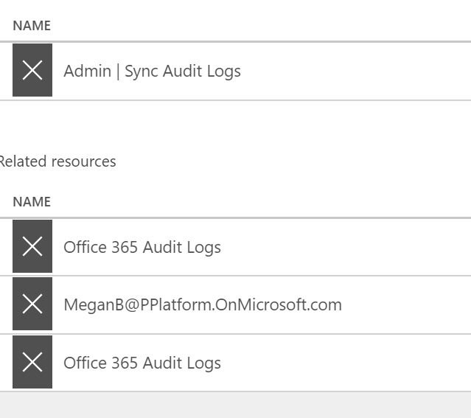

* 1. Once the connections are configured, click Import

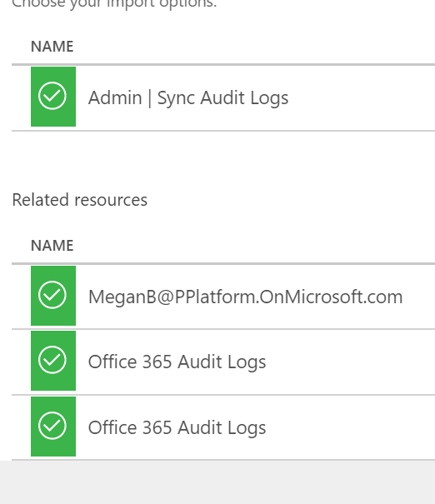

* 1. Open the flow and make sure there are no errors for any of the actions.
  2. Click the back arrow in the upper left to go back to the flow details screen. If the flow is not yet on, turn on the flow and run it to start syncing audit log data to the CDS entity.

## Step 6: Configure the Power BI Dashboard

Instructions

1. Get the organization URL
   1. Go to the Power Platform Admin Center (<https://aka.ms/ppac>)
   2. Click on Environments, and select the Environment where the Center of Excellence solution is installed
   3. Copy the organization URL in the details window.

* 1. If the URL is cut off, you can see the full URL by clicking See all > Environment URL

1. Open the **PowerPlatformAdminDashboard.pbix** file, which can be found in the CoE Starter Kit pack you downloaded.
2. Sign-in to your account that has access to the entities.
3. Go to **Edit Query** in the top ribbon (under Home).

1. Select the OrgUrl parameter and replace the URL with your instance’s URL. Make sure to keep the ‘http**s**://’.  
   A screenshot of a cell phone

   Description automatically generated
2. Click **Edit Credentials**

1. Sign-in to your Organizational account. Once signed in, click **Connect**.
2. A preview of the data will load into your table.

1. Click **Publish**, you will see a link to the report in the presented dialog.
2. You can find the report later by navigating to <https://app.powerbi.com/>
3. Click **Close & Apply**.

## Step 7: Share apps with other admins

The Core Components solution does not contain any apps for makers or end users, but only admin specific apps.

The user account who uploaded the solution and the Environment admin of the Environment the solution exists in will have full access to the solution, however you might want to share these apps with specific other users. Find more information on sharing in [this blog](https://docs.microsoft.com/en-us/powerapps/maker/canvas-apps/share-app).

These components are designed to give admins better visibility and overview of resources and usage in their environments. None of the components are to be shared with makers or end users.

## Step 8: Wait for Flows to Complete

Once the Sync Flows have finished running (depending on the number of environments and resources, this can take a few hours) you are ready to use the Core Components of the CoE Starter Kit.

You initiated these as the last step of the Activation step. To check on status:

1. Click on Admin | Sync Template v2
2. This will open a new tab to the flow’s details page.
3. View the Runs

#### Core Installation Complete

Congratulations, the Core Components are now installed. If you would like to install the other two components, please continue on below, else return to [CoE Starter Kit - Documentation and Setup Instructions.pdf](https://github.com/microsoft/powerapps-tools/blob/master/Administration/CoEStarterKit/CoE%20Starter%20Kit%20-%20Documentation%20and%20Setup%20Instructions.pdf) and learn about the elements of the solution you have installed.

# Audit and Report components - Setup Instructions

There are multiple components provided in this starter kit, each will require some configuration to install. The installation instructions have been segmented based on the set of components that should be grouped and installed together, and dependencies on other segments are outlined in each section.

## Step 1: Import the solution

Description

This is the first setup step of the installation process and is required for any other component in the starter kit to work.

Dependency

The Audit and Report Components solution requires the Core Components solution to be installed first.

Instructions

1. Follow the instructions detailed under **Core components - Import Instructions**
2. Import the CenterOfExcellenceAuditComponents_x_x_x_xx_managed.zip

## Step 2: (Optional) Create a SharePoint document library

Description

The Archive and Clean Up Flows archive apps to a SharePoint library. If you are intending to make use of those flows, a SharePoint site and document library need to be configured first.

Dependencies

The Admin | Archive and Clean Up Flow depends on a SharePoint document library.

INSTRUCTIONS

1. Follow the steps described under [Create a team site in SharePoint](https://support.office.com/en-us/article/create-a-team-site-in-sharepoint-ef10c1e7-15f3-42a3-98aa-b5972711777d) to create a new Team Site
2. Follow the steps described under [Create a document library in SharePoint](https://support.office.com/en-us/article/create-a-document-library-in-sharepoint-306728fe-0325-4b28-b60d-f902e1d75939) to add a Document Library to your new Team Site. Name the document library **PowerAppsArchive**
3. Ensure you set up the correct permissions for your SharePoint site, we would recommend only your Admin team should have contribute access to the site.

## Step 3: (Optional) Create an azure ad security group

Description

The Admin | Find and add admins as owners for apps that leverage certain connectors flow adds the Admin Security Group to apps; it is therefore required to configure the Admin Security Group first.

If you already have a security group ready, go to <https://portal.azure.com/> and get its Object ID

Dependencies

The Admin | Find and add admins as owners requires an Azure AD Security Group.

Instructions

1. Follow the steps described here to create a new Azure AD Group: [active directory groups create azure portal](https://docs.microsoft.com/en-us/azure/active-directory/fundamentals/active-directory-groups-create-azure-portal)
2. Once created, add your Admin team to the Azure AD Security Group
3. Make note of the **Object Id** of the Group which is needed to share an app with your group.  
   A screenshot of a cell phone

   Description automatically generated

## Step 4: Update Environment Variables

Description

This step should be completed after the first step above. The Environment Variables are used to store application and flow configuration data. This means, you only have to set the value once and it will be used in all necessary flows and apps.

Dependencies

All flows in this solution depend on all Environment Variables being configured.

Instructions

1. Go to the **Default Solution** solution.
   1. Navigate to <https://make.powerapps.com> and set the current Environment to the same Environment where the Center of Excellence solution is installed
   2. In the left navigation, click on **Solutions**, then select the **Default Solution** solution
2. You will see an error at the top, notifying you that Environment Variables need to be configured.   
   Note: For the Audit and Report Components solution, it will be **4** environment variables that need to be configured.  
   
3. Follow the steps under **Step 3: Update Environment Variables** to update the environment variables for the Audit and Report components solution.

|  |  |
| --- | --- |
| Archive Site URL (SharePoint Site) | The Archive and Clean Up Flow archives app files (.msapp) to a SharePoint site. Paste the URL of the Team site you created under [Step 2 above](#_Step_2:_(Optional)) here. Leave blank if you are not planning to use the Archive and Clean Up Flow. |
| Archive Folder | Folder (Document Library) within the above SharePoint site, where the .msapp file should be stored. Paste the Name of the Document Library you created under [Step 2 above](#_Step_2:_(Optional)) here. Leave blank if you are not planning to use the Archive and Clean Up Flow. |
| Developer Compliance Center | Navigate to the details page of the Developer Compliance Center (Canvas App), part of this solution and copy the Web Link (to launch the app) and paste it into this variable. |
| Power Platform Admin Security Group | The Admin | Find and add admins as owners for apps that leverage certain connectors flow adds the Admin Security Group to apps; it is therefore required to configure the Admin Security Group first – enter the Azure AD Group ID (Object Id) of the group you created under Step 3 here. Note: Make sure to enter the Object Id, not an email address. |

## Step 5: iNITIALIZE Flow APPROVAL Entities IN YOUR ENVIRONMENT

Description

The Admin | App Archive and Clean Up – Start Approval and Admin | App Archive and Clean Up – Check Approval flows use the in-built Approval actions of flow. In the background, the in-built Approval actions use CDS. If you have installed the solution in a blank new environment, the Approval entities need to be initialized first. The easiest way to do this is to create a dummy approval flow.

Dependencies

The Admin | App Archive and Clean Up – Check Approval relies on the Approval entities being present.

Instructions

1. Navigate to flow.microsoft.com
2. Click on + Create
3. Select “Instant Flow”
4. Pick “manually trigger a flow” as trigger, and enter Admin | Dummy Approval Flow as name  
   A screenshot of a computer

   Description automatically generated
5. Select + New Step to add an approval action to the flow, search for and select “Create an approval”
6. Select a dummy title and put your email address under “Assigned To”  
   A screenshot of a cell phone

   Description automatically generated
7. Select Test in the top right corner, and pick “I’ll perform the trigger action”
8. Click **Save & Test**A screenshot of a cell phone

   Description automatically generated
9. Click **Run Flow**  
   A screenshot of a cell phone

   Description automatically generated
10. This flow can take up to ten minutes to run initially. Once run, you can delete the flow as it will not be needed anymore  
    A screenshot of a social media post

    Description automatically generated
11. Click on Solutions in the right-hand side, and you should now see two new flow Approvals solutions.

Note that the presence of these solutions was the point of this step, and the way you know it succeeded. You initialized flow solutions for the environment.

## Step 6: Activate the Flows

Description

This Compliance and Report solution contains five flows:

1. Admin | App Archive and Clean Up – Start Approval
2. Admin | App Archive and Clean Up – Check Approval
3. Admin | Compliance detail request
4. SETUP REQUIRED | Admin | Find and add admins as owners for apps that leverage certain connectors
5. SETUP REQUIRED | Admin | Find and disable flows that leverage certain connectors

Instructions

Follow the same instructions to configure the flows as mentioned under Step 4: Activate the Sync Template Flows

## Step 7: Share apps with Makers

The Audit and Report Components solution contains one app, which is used by makers to update compliance details of their application.

1. Developer Compliance Center

Once you are ready to open the CoE to the makers of Apps and flows, share this Application with them. Your makers must have a Power Apps Premium license, as mentioned under Prerequisites.

#### Audit and Report Installation Complete

Congratulations, the Audit and Report Components are now installed. If you would like to install the last component, please continue on below, else return to [CoE Starter Kit - Documentation and Setup Instructions.pdf](https://github.com/microsoft/powerapps-tools/blob/master/Administration/CoEStarterKit/CoE%20Starter%20Kit%20-%20Documentation%20and%20Setup%20Instructions.pdf) and learn about the elements of the solution you have installed.

# Nurture components - Setup Instructions

There are multiple components provided in this starter kit, each will require some configuration to install. The installation instructions have been segmented based on the set of components that should be grouped and installed together, and dependencies on other segments are outlined in each section.

## Step 1: Import the solution

Description

This is the first setup step of the installation process and is required for any other component in the starter kit to work.

Dependency

The Nurture Components solution requires the Core Components solution to be installed first.

Instructions

1. Follow the instructions detailed under **Core components - Import Instructions**
2. Import the CenterOfExcellenceNurtureComponents_x_x_x_xx_managed.zip

## Step 2: Update Environment Variables

Description

This step should be completed after the first step above. The Environment Variables are used to store application and flow configuration data. This means, you only have to set the value once and it will be used in all necessary flows and apps.

Dependencies

All flows in this solution depend on all Environment Variables being configured.

Instructions

1. Go to the **Default Solution** solution.
   1. Navigate to <https://make.powerapps.com> and set the current Environment to the same Environment where the Center of Excellence solution is installed
   2. In the left navigation, click on **Solutions**, then select the **Default Solution** solution
2. You will see an error at the top, notifying you that Environment Variables need to be configured.   
   Note: For the Audit and Report Components solution, it will be **2** environment variables that need to be configured.  
   
3. Follow the instructions under **Step 3: Update Environment Variables** to configure the environment variables for the Nurture components solution

|  |  |
| --- | --- |
| Power Platform Maker Office 365 Group | The Admin | Welcome Email Flow sends a welcome email to onboard new makers, and adds them to an Office 365 Group – you can use this group to send comms to your makers or invite them to a Yammer/Teams group. Configure the Group ID here. |
| Training in a day – Feedback Form | The Training in a day package includes a flow that automatically sends a feedback request to attendees on the day of the event. Configure the Form URL (<https://forms.office.com/>...) here. |

## Step 3: Activate the Flows

Description

This solution contains five Flows:

1. Admin | Newsletter with Product Updates
2. Admin | Welcome Email
3. Training in a day | Feedback Reminder
4. Training in a day | Registration Confirmation
5. Training in a day | Reminder 3 days prior to event

Instructions

Follow the same instructions to configure the flows as mentioned under **Step 4: Activate the Sync Template Flows**

## Step 5: Share apps with Makers

The Nurture Components solution contains four app. Once you are ready to open the CoE to the makers of Apps and flows in your organization, share the below with them.

1. App Catalog – to be shared with entire organization
2. Template Catalog – to be shared with your makers or entire organization
3. Training in a day Management – to be shared with admins only
4. Training in a day Registration – to be shared with entire organization

All end users must have a Power Apps Premium license, as mentioned under **Prerequisites**.

#### Nurture Installation Complete

Congratulations, the Nurture Components are now installed. Please return to [CoE Starter Kit - Documentation and Setup Instructions.pdf](https://github.com/microsoft/powerapps-tools/blob/master/Administration/CoEStarterKit/CoE%20Starter%20Kit%20-%20Documentation%20and%20Setup%20Instructions.pdf) and learn about the elements of the solution you have installed.